Practical 5

Part A:
Aim:
1. Shape areas: an abstract Shape with abstract area(); subclasses Circle, Rectangle, Triangle. Put a mix in a Shape[] and loop once to print each area and the running total, tracking the largest — one loop handling every shape through polymorphism.

Code:
ShapeAreas.java
public class ShapeAreas {

// Abstract parent class
static abstract class Shape {

// Abstract method
public abstract double area();
}

// Circle
static class Circle extends Shape {

private double radius;

public Circle(double radius) {
this.radius = radius;
}

@Override
public double area() {
return Math.PI * radius * radius;
}
}

// Rectangle
static class Rectangle extends Shape {

private double length;
private double width;

public Rectangle(double length, double width) {
this.length = length;
this.width = width;
}

@Override
public double area() {
return length * width;
}
}

// Triangle
static class Triangle extends Shape {

private double base;
private double height;

public Triangle(double base, double height) {
this.base = base;
this.height = height;
}

@Override
public double area() {
return 0.5 * base * height;
}
}

public static void main(String[] args) {

// Mixed array of different shapes
Shape[] shapes = {
new Circle(5),
new Rectangle(10, 4),
new Triangle(6, 8),
new Circle(3)
};

double total = 0;
double largest = 0;

// One loop handles all shapes
for (Shape shape : shapes) {

double currentArea = shape.area();

total += currentArea;

if (currentArea > largest) {
largest = currentArea;
}

System.out.printf(
"Area: %.2f | Running Total: %.2f%n",
currentArea,
total
);
}

System.out.printf("%nTotal Area: %.2f%n", total);
System.out.printf("Largest Area: %.2f%n", largest);
}
}

Output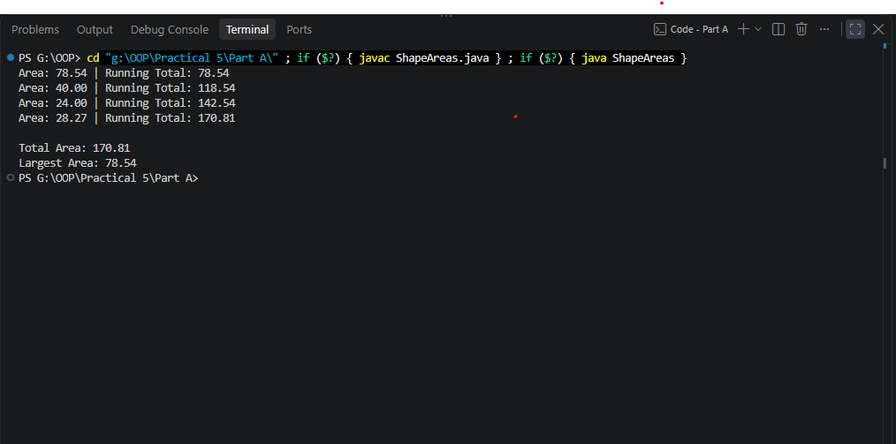

2. Payroll: an abstract Employee with abstract monthlySalary(); FullTime (fixed), PartTime (hours × rate) and Intern (stipend), each calling super for the shared name/id. Loop a mixed array to print each salary and the total; use instanceof to add a note only for interns.

Code:
Payroll.java
public class Payroll {

// Abstract Employee class
static abstract class Employee {

protected String name;
protected String id;

// Constructor
public Employee(String name, String id) {
this.name = name;
this.id = id;
}

// Abstract salary method
public abstract double monthlySalary();

public String getName() {
return name;
}

public String getId() {
return id;
}
}

// Full-time employee
static class FullTime extends Employee {

private double fixedSalary;

public FullTime(String name, String id, double fixedSalary) {
super(name, id);
this.fixedSalary = fixedSalary;
}

@Override
public double monthlySalary() {
return fixedSalary;
}
}

// Part-time employee
static class PartTime extends Employee {

private int hours;
private double rate;

public PartTime(
String name,
String id,
int hours,
double rate) {

super(name, id);
this.hours = hours;
this.rate = rate;
}

@Override
public double monthlySalary() {
return hours * rate;
}
}

// Intern
static class Intern extends Employee {

private double stipend;

public Intern(String name, String id, double stipend) {
super(name, id);
this.stipend = stipend;
}

@Override
public double monthlySalary() {
return stipend;
}
}

public static void main(String[] args) {

Employee[] employees = {
new FullTime("Rahul", "E001", 50000),
new PartTime("Priya", "E002", 80, 500),
new Intern("Amit", "E003", 15000),
new FullTime("Sara", "E004", 60000)
};

double totalSalary = 0;

for (Employee employee : employees) {

double salary = employee.monthlySalary();

totalSalary += salary;

System.out.println(
employee.getName()
+ " (" + employee.getId() + ")"
+ " Salary: Rs. "
+ salary
);

// Pattern instanceof
if (employee instanceof Intern intern) {
System.out.println(
" Note: " + intern.getName()
+ " is an intern."
);
}
}

System.out.println("----------------------------");
System.out.println("Total Payroll: Rs. " + totalSalary);
}
}

Output
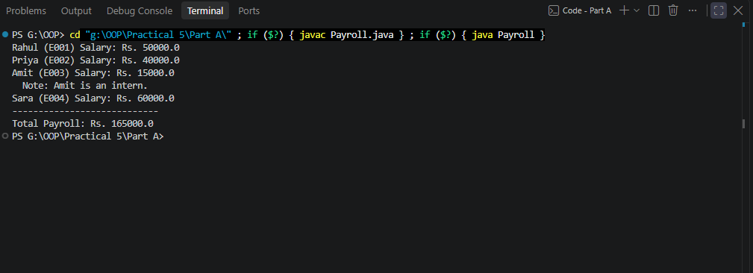

3. (For Advanced Learners – home) Model a few media types that each compute a late fee differently and total the fees for a returned batch. Design the hierarchy and rules yourself.

Design
Media (abstract)
│
├── Book
├── DVD
└── Magazine
Each subclass overrides lateFee(int lateDays).
Fee Rules
Media Type | Late Fee Rule
Book | ₹2 per late day
DVD | ₹5 per late day
Magazine | ₹1 per late day

We'll store all media in a Media[] array and calculate the total late fee using runtime polymorphism.

Code:
Media.java
public abstract class Media {

private String title;

public Media(String title) {
this.title = title;
}

public String getTitle() {
return title;
}

// Each media type calculates its own fee
public abstract double lateFee(int lateDays);

@Override
public String toString() {
return title;
}
}
Book.java
public class Book extends Media {

public Book(String title) {
super(title);
}

@Override
public double lateFee(int lateDays) {
return lateDays * 2.0;
}
}
DVD.java
public class DVD extends Media {

public DVD(String title) {
super(title);
}

@Override
public double lateFee(int lateDays) {
return lateDays * 5.0;
}
}

Magazine.java
public class Magazine extends Media {

public Magazine(String title) {
super(title);
}

@Override
public double lateFee(int lateDays) {
return lateDays * 1.0;
}
}

MediaDemo.java
public class MediaDemo {

public static void main(String[] args) {

Media[] returnedMedia = {
new Book("Java Programming"),
new DVD("Inception"),
new Magazine("Technology Today"),
new Book("Data Structures"),
new DVD("Interstellar")
};

int[] lateDays = {
3,
2,
5,
4,
1
};

double totalFee = 0;

System.out.println("=== Returned Media ===");

for (int i = 0; i < returnedMedia.length; i++) {

double fee = returnedMedia[i].lateFee(lateDays[i]);

System.out.println(
returnedMedia[i].getClass().getSimpleName()
+ " - "
+ returnedMedia[i].getTitle()
+ " - "
+ lateDays[i]
+ " late days - Fee: ₹"
+ fee
);

totalFee += fee;
}

System.out.println("\nTotal Late Fee: ₹" + totalFee);
}
}

Output
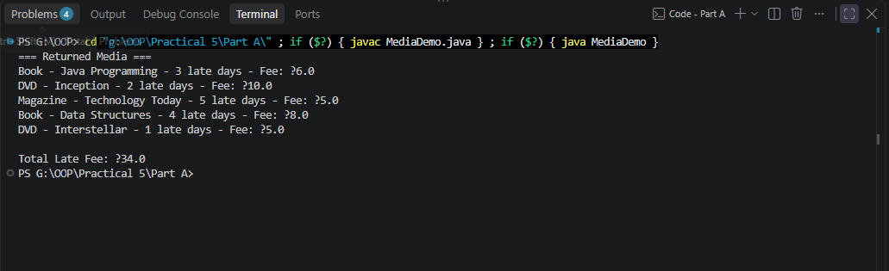

Key Questions / Analysis / Interpretation to be evaluated during/after Implementation
- What is the difference between an abstract class and a concrete class?

Ans.
Abstract Class | Concrete Class
Declared using abstract keyword. | Normal class without abstract.
Cannot be instantiated directly. | Can be instantiated using new.
Can contain abstract methods (methods without a body). | Must provide implementations for inherited abstract methods.
Used to define a common structure/behavior for subclasses. | Represents a complete, usable implementation.
Example: abstract class Account | Example: class SavingsAccount extends Account

- What is dynamic method dispatch (run-time polymorphism)?

Ans.
Dynamic method dispatch is the mechanism by which Java decides at run time which overridden method should be executed based on the actual object, not the reference type.
It is the basis of run-time polymorphism.
Example:
Account a;

a = new SavingsAccount("Rahul", 10000, 2000);

System.out.println(a.interestRate());

- What does the super keyword do in a subclass constructor?

Ans.
The super keyword is used to access members of the parent class. In a subclass constructor, super(...) specifically calls the parent class constructor.
Example:
class Account {
Account(String ownerName, long balance) {
// initialize account
}
}

class SavingsAccount extends Account {
SavingsAccount(String ownerName, long balance, long minBalance) {
super(ownerName, balance);
this.minBalance = minBalance;
}
}

